Hello again. In this video, we are going to discuss three types of questions which we can use to make our language less direct. Let's begin then.

The most common way to ask a polite question is to make your question indirect.

Let’s look at a few examples. For instance, you need to urge a colleague to finish a task. You can ask  *‘What do you need to get this task done?* But if we ask an indirect questions, it becomes a lot more polite. For example, *Could you tell me what you need to get this task done?’.*

Another example – imagine you arrive late for a meeting and, to make things worse, you don’t know where it is taking place, so you can ask a very direct question:*Where is the meeting room?,* which is fine, but could be considered a little rude. We can soften it by using an introductory phrase: *Do* *you happen to know where the meeting room is?*

There are a few introductory phrases for building indirect questions, they are  *Could you tell me…, Do you happen to know…, Do you know…, I was wondering/I wonder, Do you have any idea…, May I ask.*

*Please* keep in mind, however, that in order to make an indirect question you need to follow certain grammar rules.

For more details you can visit the section  **GRAMMAR NOTE** in this lesson.

Overall, indirect questions increase the level of politeness and, therefore, they are particularly useful when we ask somebody we don't know very well.

Another type of polite questions are negative questions.

Imagine that you have some concerns about implementing a risky solution. You could say: *We will be taking a huge risk.* This message offers only one point of view, your opinion. If, however, we turn it into a negative question:  ***Wouldn’t we be taking a huge risk?***, we also invite the listener to take part in the decision-making process.

One more example, *It is better to discuss this proposal with other team members.* In this sentence we express our opinion quite directly about the need to discuss the proposal with other colleagues. By turning the sentence into a negative question, *Wouldn’t it be better to discuss this proposal with other team members?* we not only make our opinion sound less direct, but also encourage the listeners to agree with it.

So , you can form negative questions using shouldn’t, wouldn’t, don’t, won’t, etc. The major benefit of such questions is that they leave some room for discussion and can help you be more persuasive, which can be extremely useful in negotiations.

The last type of questions we are going to discuss are **question tags.**

Question tags can help us sound more polite in a few ways. Let’s take a look: *These new sales figures are promising.* This sentence on its own is just an announcement. It doesn’t encourage any form of response. We can invite the listener to agree with us by adding a tag, for example *These new sales figures are promising, aren’t they?* Question tags can be particularly helpful during presentations by keeping the audience involved.

Tags come in handy also for **softening our suggestions**. For example**:** *Let’s start the meeting.* By adding a tag, we make it more polite: *Let’s start the meeting, shall we?*

To sum up, question tags can be used to encourage interaction and make suggestions softer.

In order to build question tags you need to follow certain grammar rules. For more details you can visit the section GRAMMAR NOTE in this lesson.

*In this table you will find all the diplomatic questions we’ve covered in this video:*

Indirect questions

Negative questions, and

Questions tags.

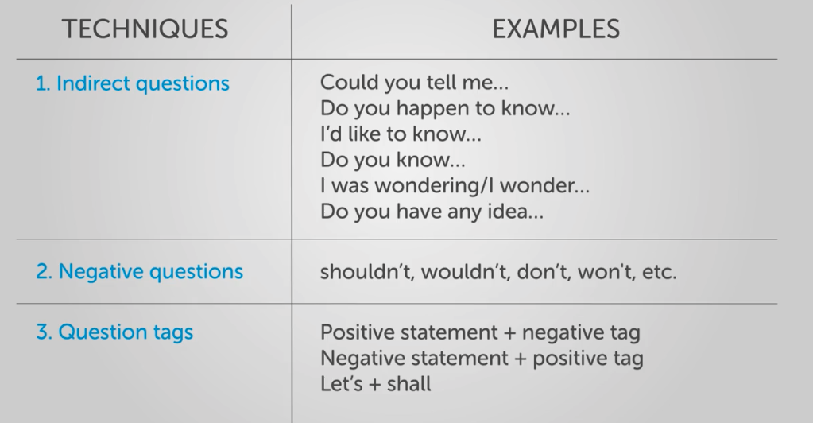

I hope you’ve found this information useful.

Now please move on to the exercises to practice making your speech more diplomatic.

**Grammar note: indirect questions**

**SAMPLE QUESTIONS**

*I’d like to know what the deadline is.*

*Could you tell me how long it will take?*

*We wonder if we could move the release date.*

*Do you have any idea if he has finished the tests?*

**FORM**

**Introductory phrase + question word + positive sentence\***

**Introductory phrase + if/whether + positive sentence\***

*\*positive sentence: subject + verb + other sentence parts*

**Introductory phrases:**

*Do you know …*

*I wonder / was wondering ….*

*Can / Could you tell me …*

*Do you happen to know ...*

*Do you have any idea ...*

*Would you mind telling me…*

*May I ask…*

*I'd like to know …*

**RULES OVERVIEW:**

1)   Questions with **question words**: **'where', 'what', 'when', 'how', 'why' and 'which', etc.**

  Standard question: ***When****is the deadline?*

***How long****will it take?*

Indirect Question: **Introductory phrase + question word + positive sentence**

Indirect Question: ***I’d like to know when****the deadline is.*

***Could you tell me how long****it will take?*

2)   Questions with **auxiliaries: ‘do/does’, ‘have/has’, ‘was/were’, ‘will’, ‘can’, ‘could’, ‘may’, ‘might’**, etc.

Standard question: ***Could****we move the release date a bit?*

***Has****he finished the tests?*

Indirect Question: **Introductory phrase + if/whether + positive sentence**

Indirect Question: ***We wonder if****we could move the release date a bit.*

***Do you have any idea whether****he has finished the tests?*

**Grammar note: tag questions**

**SAMPLE SENTENCES**

*The reports are ready, aren't they?*

*They make electric cars, don't they?*

*You won't forget, will you?*

*They can't both be right, can they?*

**FORM**

We normally form question tags in the following way:

**positive verb + negative tag**

**negative verb + positive tag**

e.g.

We **are**meeting next week, **aren't we?**

We **aren't**meeting next week, **are we?**

**RULES OVERVIEW:**

**1.** If the statement uses **a modal verb**, it is repeated in the tag, e.g.

*You****can****finish the testing,****can’t****you?*

*You****shouldn’t****reply immediately,****should****you?*

**2.** With the **Simple Present Tense** we use *do / does* OR *don’t / doesn't*?

With the **Simple Past Tense**we use *did / didn't?*, e.g.

*They****work****overtime a lot,****don’t****they?*

*You****didn’t****see**the presentation yesterday,****did****you?*

**3.** With **other tenses**, we just use the auxiliary, e.g.

*They****haven’t****performed the testing yet,****have****they?*

*We****will****deliver on time,****won’t****we?*

**4.** If the subject of the statement is **somebody, anybody, nobody, everybody, no one, and neither** …. We use the pronoun **‘they’** in question tag, e.g.

***Somebody****entered the garden, didn't****they****?*

***Everybody****was upset, weren't****they****?*

**\*EXCEPTIONS**

**1.** After **‘I am’**the tag is **‘aren't’**, e.g.

*I am late,****aren't****I?*

*BUT: I am not late, am I?*

**2.** After **‘let’s’** the tag is ‘shall’, e.g.

***Let's****go to the beach,****shall****we?*